NN&DeepLearning_ICP10: LSTM

**NAME: BALA RISHIK MARNENI**

**STUDENT ID: 700746746**

**GITHUB LINK**[**: https://github.com/BalaRishik001/Neural-Networks-and-Deep-Learning-Assignments**](https://github.com/BalaRishik001/Neural-Networks-and-Deep-Learning-Assignments)

**VIDEO LINK:** [**https://drive.google.com/file/d/18tpri2uRNUjSCQWyNBqvRRbyJU9BNcrI/view?usp=drive_link**](https://drive.google.com/file/d/18tpri2uRNUjSCQWyNBqvRRbyJU9BNcrI/view?usp=drive_link)

# Lesson Overview:

In this lesson, we are going to discuss types of ANNs and Recurrent Neural Network.

# Use Case Description:

1. Sentiment Analysis on the Twitter dataset

# Programming elements:

1. Basics of LSTM
2. Types of RNN
3. Use case: Sentiment Analysis on the Twitter data set

# In class programming:

* 1. Save the model and use the saved model to predict on new text data (ex, “**A lot of good things are happening. We are respected again throughout the world, and that's a great thing** [.@realDonaldTrump](https://twitter.com/realDonaldTrump)”)
  2. Apply GridSearchCV on the source code provided in the class

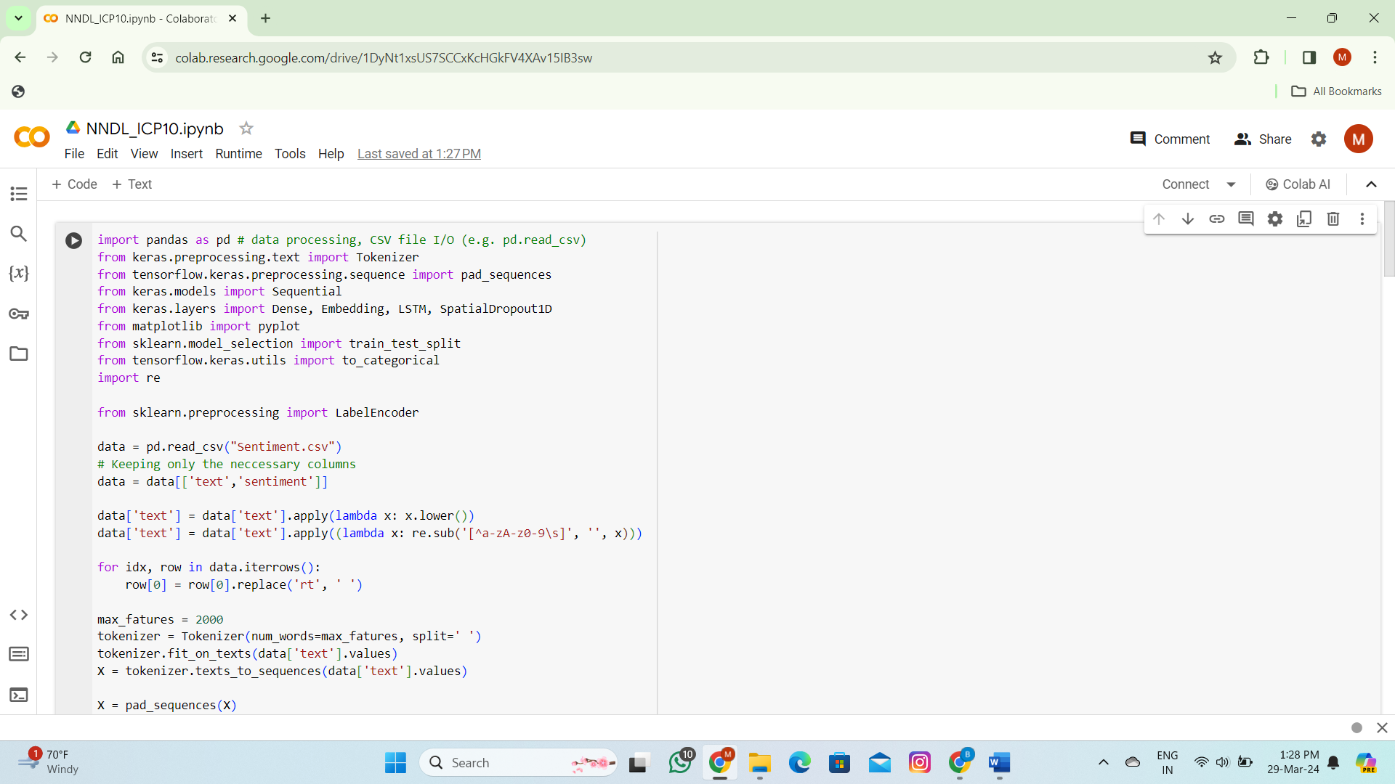

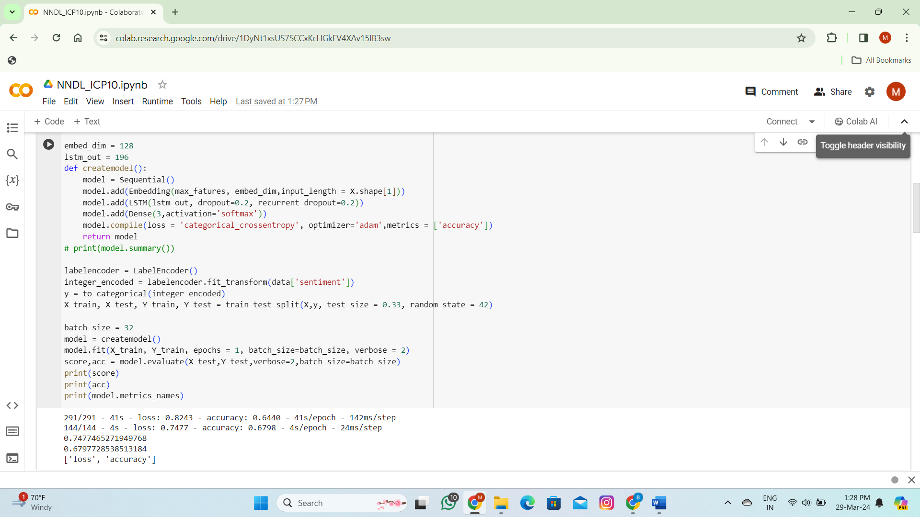

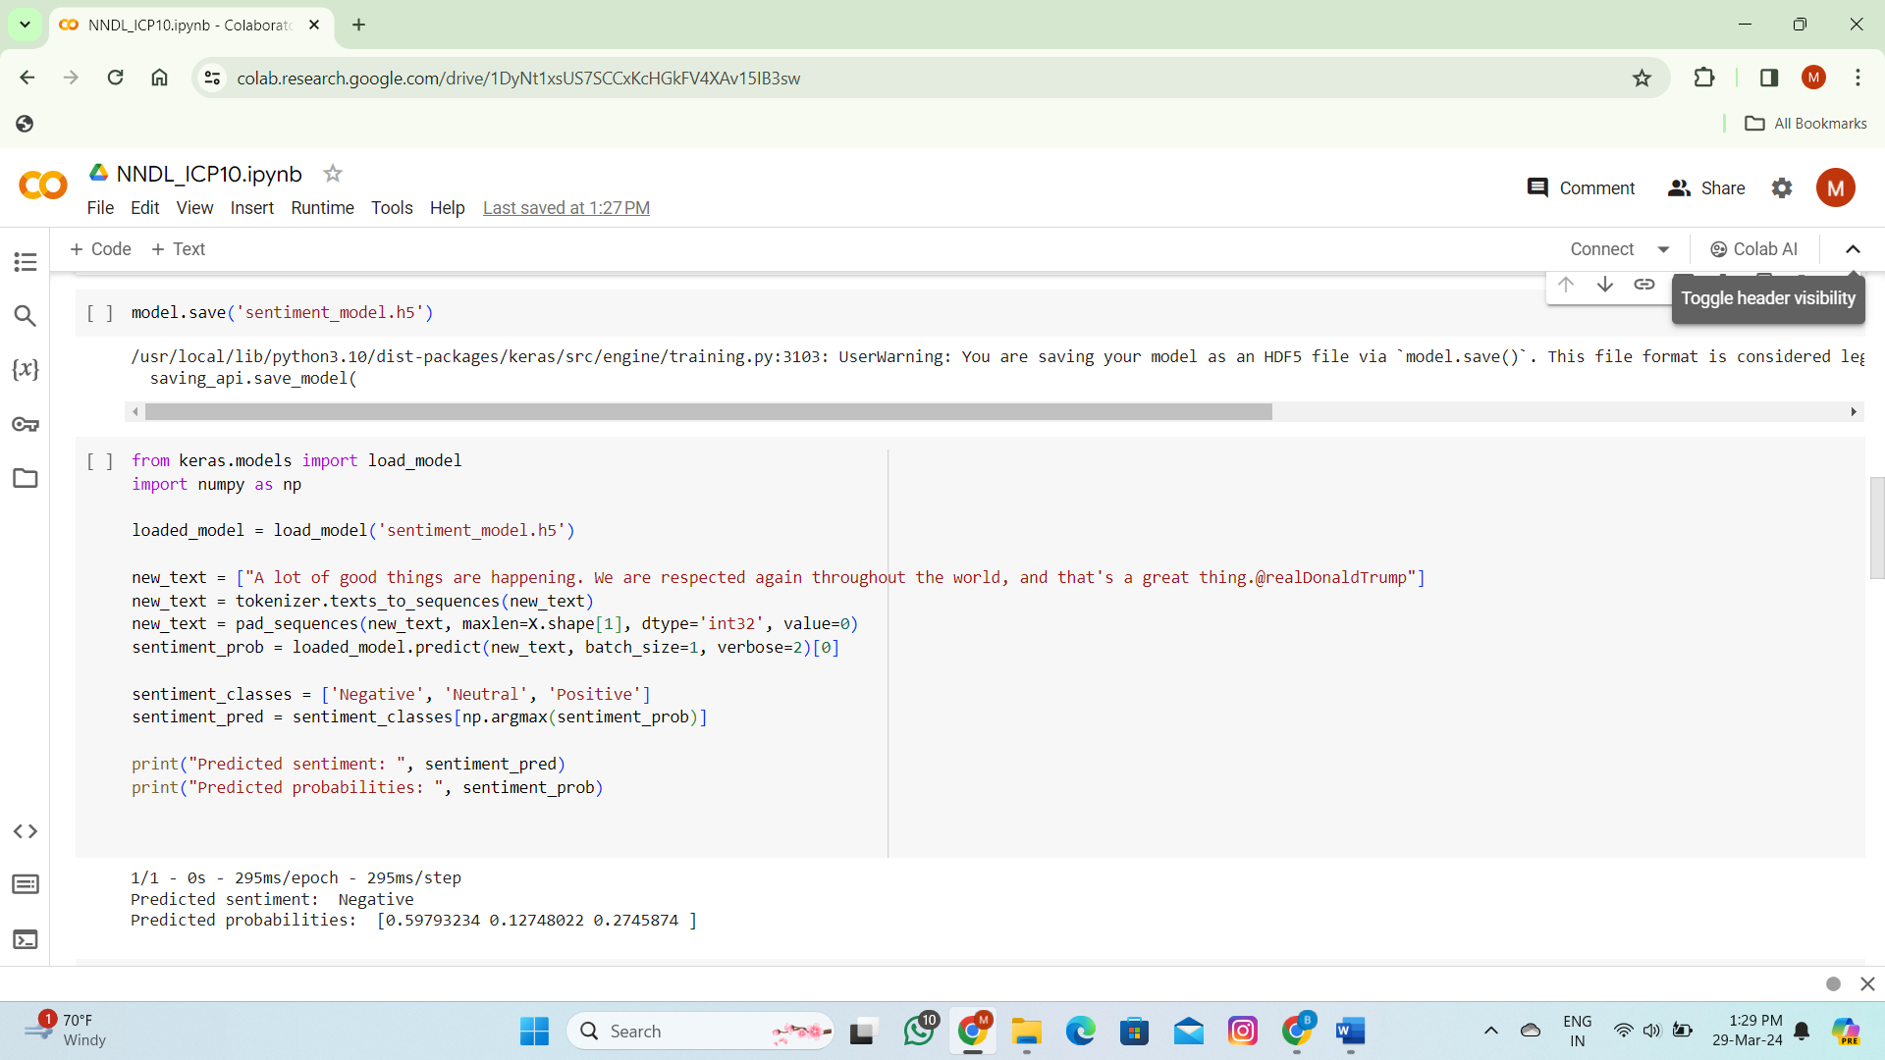

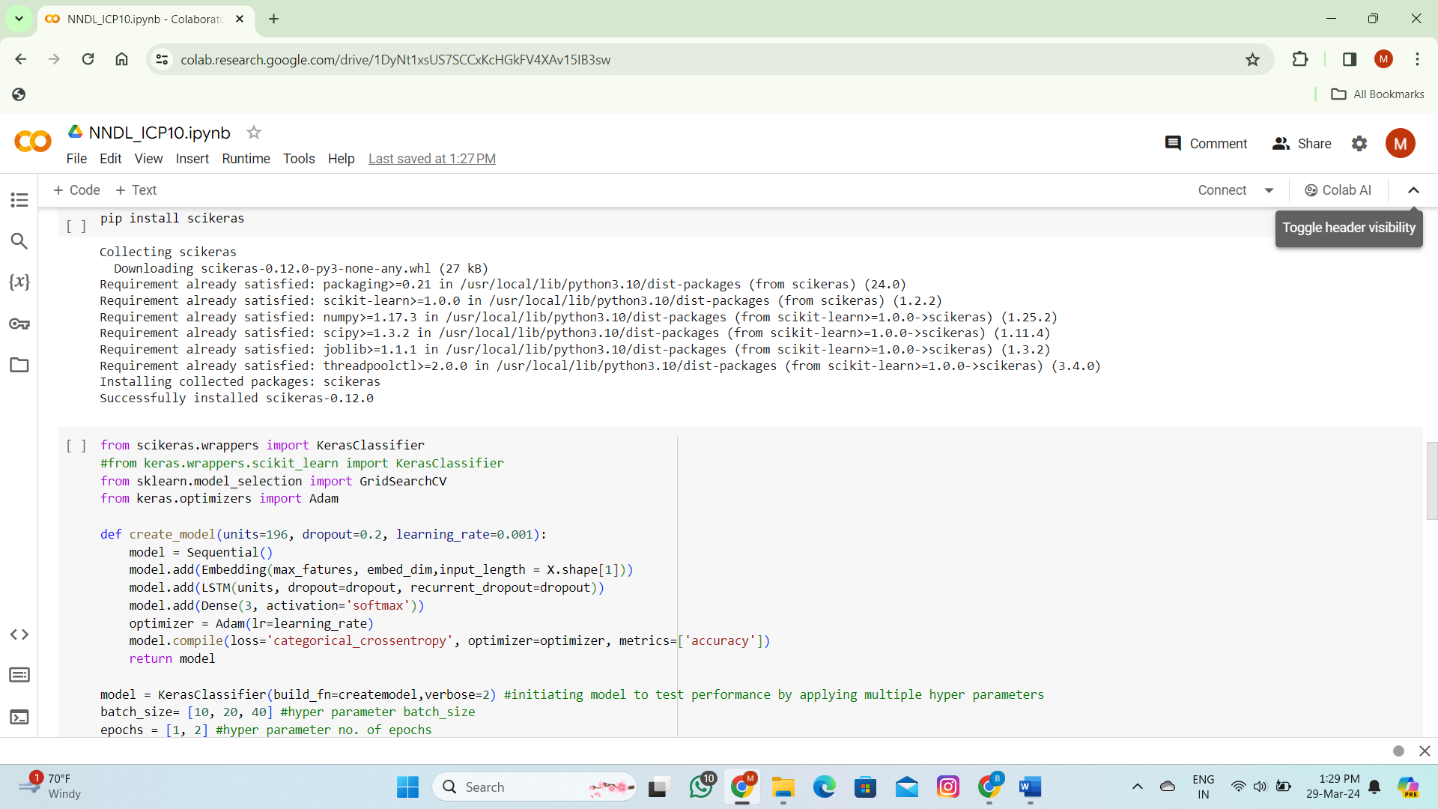

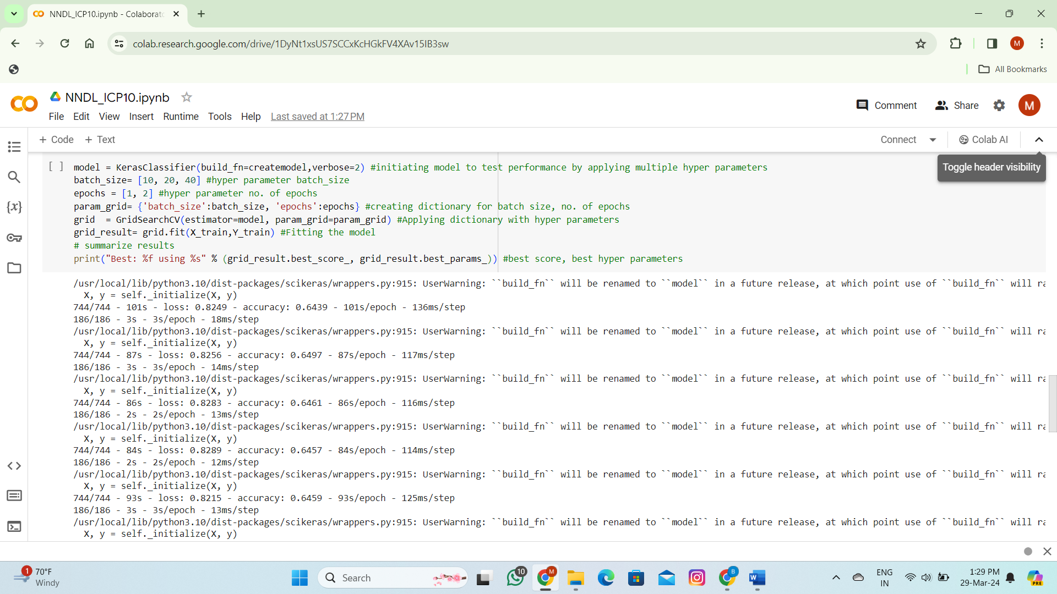

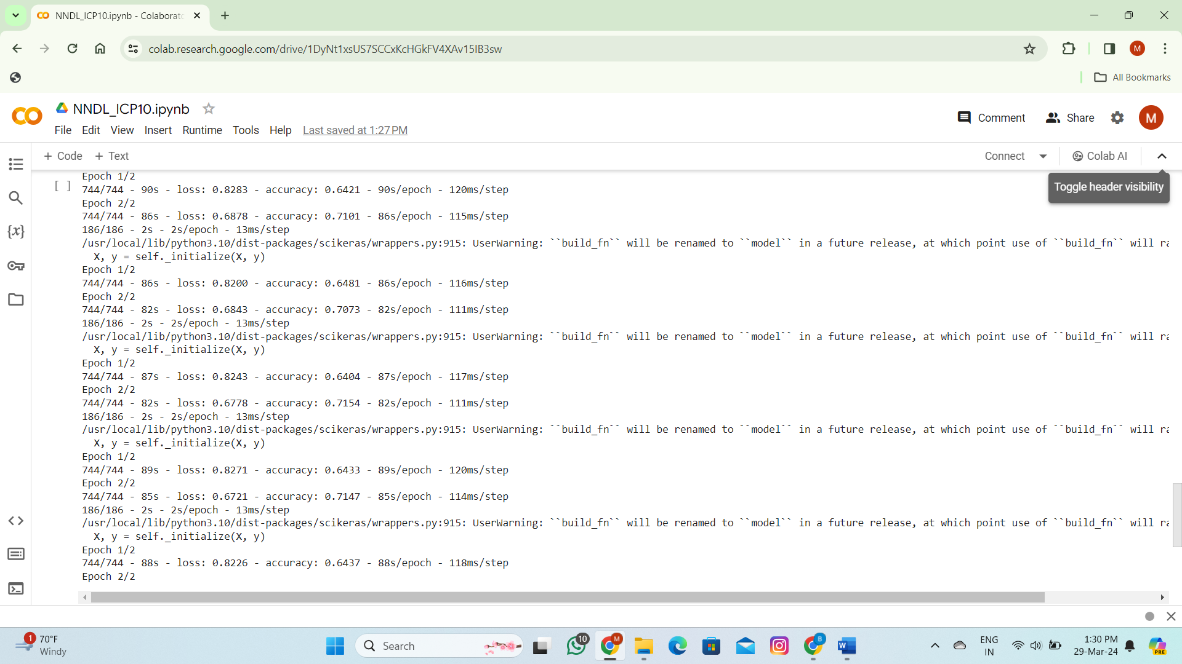

**THANK YOU**